# COMSATS University Islamabad, Abbottabad Campus

**Department of Computer Science**   Lab-Midterm Examination (Fall 2022)

|  |  |
| --- | --- |
| Class: BSE – 3B | Date: 22/11/2022 |
| Subject: Object Oriented Programming. | Instructor: Dr. Waqas Jadoon |
| Total Time Allowed:75 minutes) | Max Marks: 20 |
| Name: ____Saifullah___________________________________ | Registration #SP21-BSE-022 |

**SP21-BSE-022**

**Saifullah**

**BSE 3b**

**OOP**

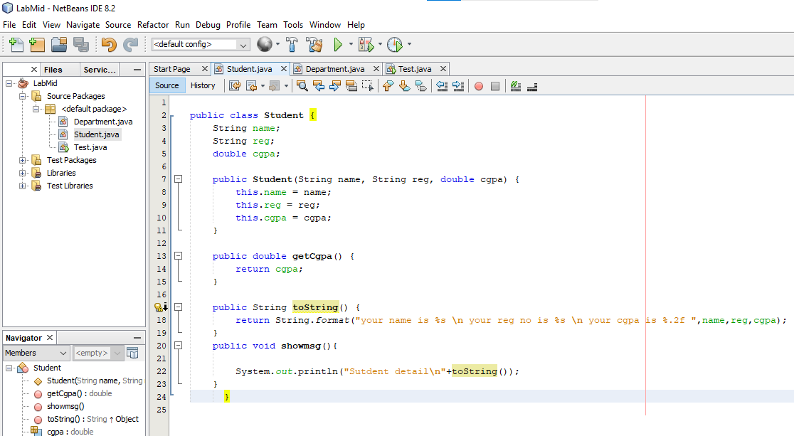**Solution:**

